# Exercises: Web Fundamentals Introduction

Problems for exercises and homework for the [“C# Web Development Basics” course @ SoftUni](https://softuni.bg/courses/csharp-web-development-basics).

## Welcome to HTML

Create a Web page like at the screenshot:

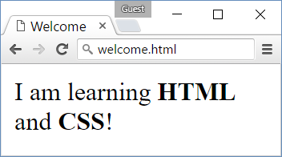

* *File name:* welcome.html
* *Title:* Welcome
* *Paragraph of text:* I am learning **HTML** and **CSS**!

### Hints

Modify the code from the examples in the slides.

## Headings

Create a Web page like the screenshot:

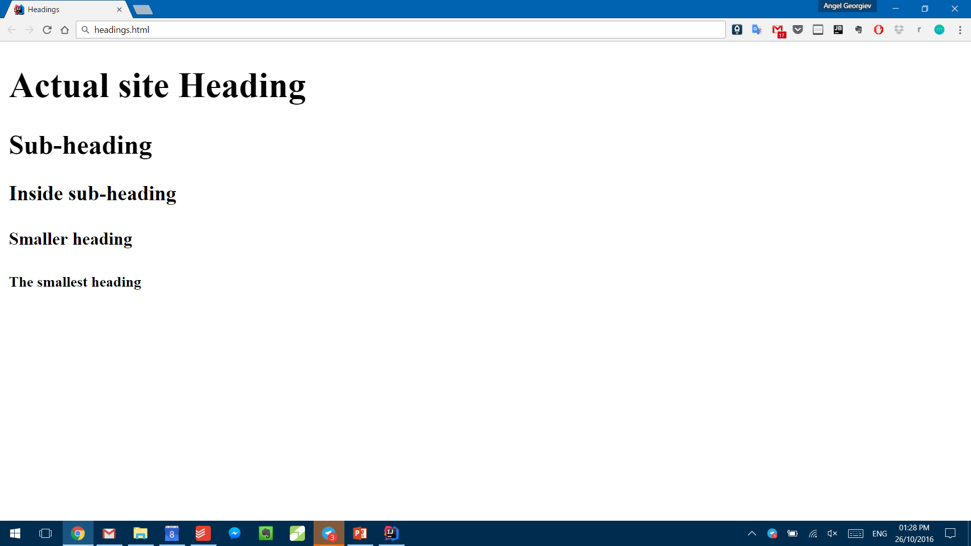

* *File name*: headings.html
* *Title:* Headings
* *Large heading:* Headings Exercise
* *Smaller headings:* First through Fourth

### Hints

Use <h1> through <h5> tags.

## Paragraphs

Create a Web page like the screenshot:

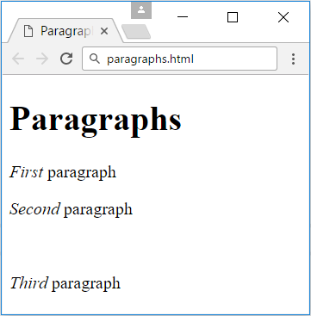

* *File name*: paragraphs.html
* *Title:* Paragraphs
* *Large heading:* Paragraphs
* *Emphasized text:* First, Second and Third
* *Empty line:* Between second and third paragraph

### Hints

Use **<p>**, **<em>** and **<br/>** tags.

## My TODO List

Create a Web page like the screenshot:

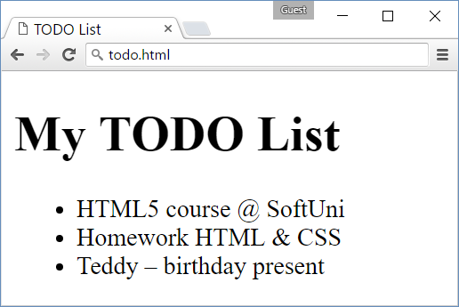

* *File name:* todo.html
* *Title:* TODO List
* *Large heading:* My TODO List
* *Unordered list:* <ul>…</ul>
* *Three list elements:* **<li>…</li>**

### Hints

* Create an HTML file named todo.html like in the previous exercises.
* Assign the <title>…<title>.
* Use <ul>…</ul> to create an unordered list.
* Put each of the list items in a <li>…</li> tag.
* Use **&amp;** for the &
* Use &ndash; for the long hyphen.

## Hello HTML

Create a Web page like the screenshot:

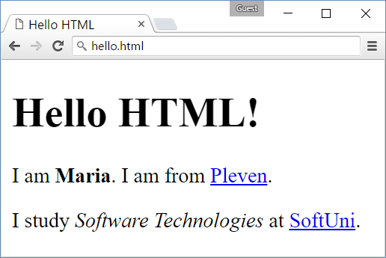

* *File name:* hello.html
* *Title:* Hello HTML
* *Large heading:* Hello HTML!
* *Paragraph of text:* I am <your name (bold)>. I am from <your town as link to your town's Web site>.
* *Paragraph of text:* I study <specialty (italic)> at <link to SoftUni>.

### Hints

Modify the code from the example in the slides.

## Website

Create three web pages connected to each other by local links like the screenshot below:

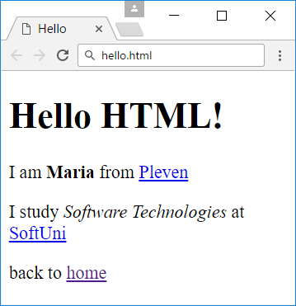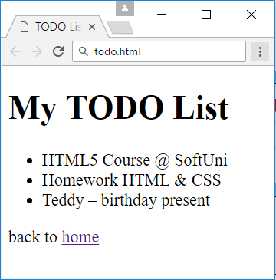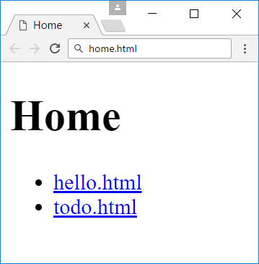

* *File names:* home.html, todo.html, hello.html
* *Titles:* Home, TODO List, Hello
* *Large headings:* Home, My TODO List, Hello HTML!
* *Unordered lists: home.html and todo.html*
* *Hyperlinks:* home.html - links to todo.html and hello.html
* *Home hyperlinks:* todo.html and hello.html

### Hints

You can use the todo.html and hello.html pages that you have created for the previous exercises.

* Create home.html and use **<ul>…</ul>** to create an unordered list with the links
* Use **<a href="">…</a>** to create a hyperlink inside a **<li>…</li>** element
* Use **href="todo.html"** to connect home.html to todo.html and **href="hello.html"** to connect it with hello.html.
* Create 'back to home' links following the same logic

## Fruits

Create a Web page like the screenshot:

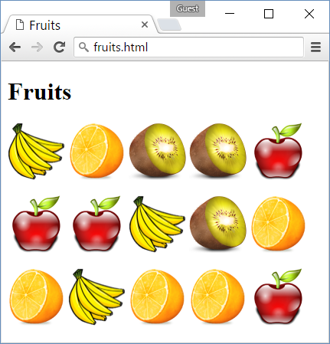

Use the fruit images given in assets:

* images\apple.png
* images\banana.png
* images\kiwi.png
* images\orange.png

### Hints

* Create a HTML page named “**fruits.html**” titled “**Fruits**”.
* Use 3 paragraphs, each holding 5 images.
* Put the images in each paragraph (row) in a sequence, one after another.

## Receipt

Design a Web page like the screenshot:

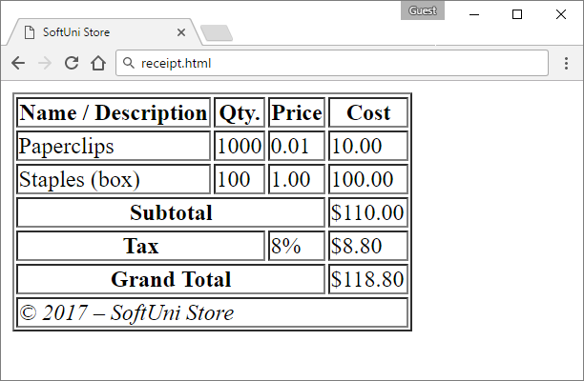

### Hints

* Create a HTML page named “**receipt.html**” titled “**SoftUni Store**”.
* Use <table>, <tr>, <th>, <td> tags and the colspan attribute.
* Use &copy; for the copyright sign.

Create a Web page like the screenshot:

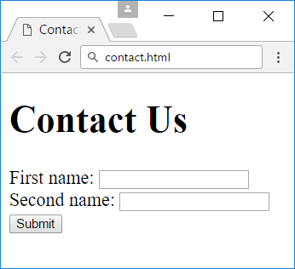

* *File name:* contact.html
* *Title:* Contact Us
* *Large heading:* Contact Us
* *Form: holding three elements*
* *Textboxes:* Two text boxes
* *Button:* with text Submit

### Hints

* For the form use **<form>…</form>**
* Inside the form place two textboxes using **<input type="text" />**
* Use **<input type="submit" value="Submit" />** for the button

## Colors

Create a Web page like the screenshot:

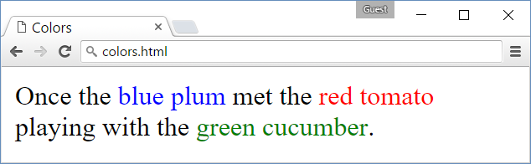

### Hints

* Use a paragraph **<p>…</p>** to hold the text.
* Use <span style="…">text</span> for the colored text

## Borders

Create a Web page like the screenshot:

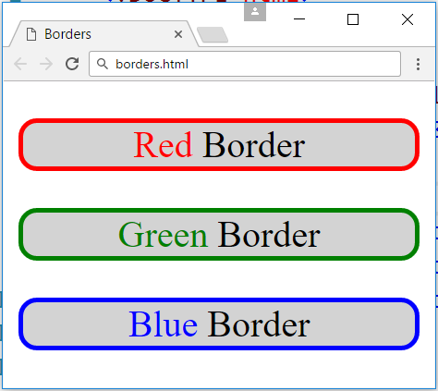

### Hints

* Use three paragraphs **<p>…</p>** to hold the text
* Use **<p style="">…</p>** to style the paragraphs
* Use <span style="…">text</span> for the colored text

## Rectangles

Create a Web page like the screenshot:

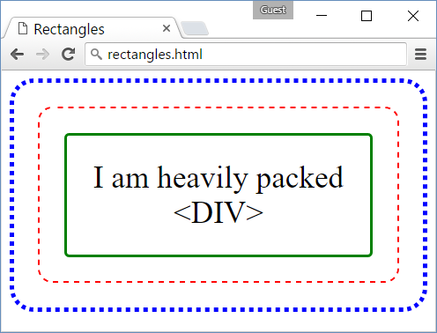

### Hints

* Use 3 nested <div> elements
* **Outside div**: blue dotted border + border-radius + padding
* **Middle div**: red dashed border + border-radius + padding
* **Inner div**: green solid border + border-radius + padding + text-align + font-size
* Use &lt; and &gt; to escape the < and > characters in the text…

## Languages

Create a Web page like the screenshot:

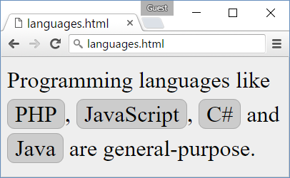

### Hints

* Create HTML file langs.html.
  + Put the text in paragraphs and <span>…</span> tags.
* Create CSS file langs.css.
* Link the CSS file in the HTML header:
  + <link rel="…" href="langs.css">
* In the **body** CSS selector in the CSS class define:
  + background:#EEE; font-size:24pt;
* Define and use a CSS class .lang for styling the languages:
  + Specify border:1px #AAA, border-radius, background:#CCC, padding

## *13. Contact Us Form

Create a Web page like the screenshot:

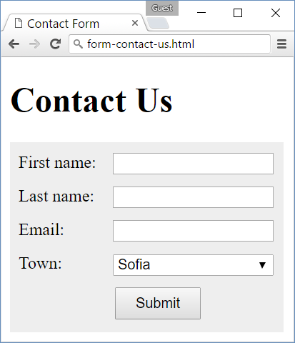

### Hints

1. Create an HTML file contact-us-form.html, put appropriate **title**, put “**Contact Us**” **heading**.
2. Create the **HTML code** to display the form and its fields:

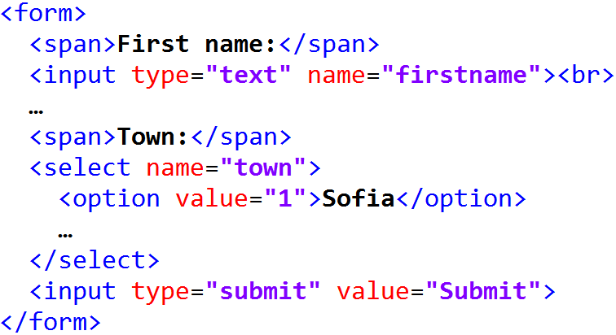

1. In the **CSS file** put some styling to make the for look like at the above screenshot. First define the form background styling:

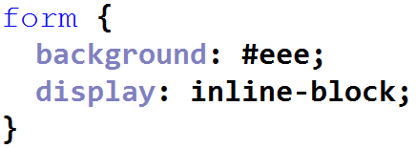

1. Style the **labels** before each form field. They stay in a <span>…</span> tags. Use styling like this:

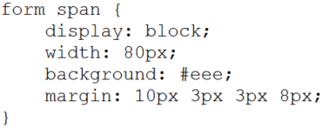

1. Now style the <input>…</input> and <select>…</select> fields:

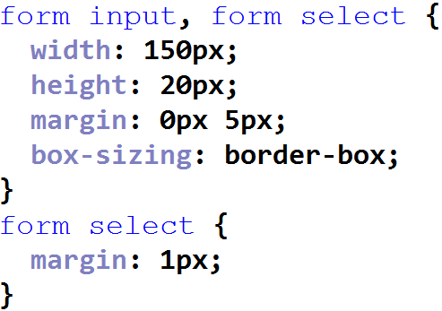

1. Finally, style the “**Submit**” button:

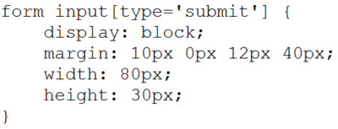

<**span class="lang" style="border**:1**px #AAA**; **border-radius**: 1**px**; **background**:**#CCC**; **padding**: 1**em"**>